Name:___________________________________ Date:_________________ PD:_____

Cotton Ball Activity – Thickness of the Ozone Layer

Gently place the cotton balls in a graduated cylinder so they just barely touch each other.

1. How many cotton balls fit in the graduated cylinder? ___________________________

Next, use the chopstick to push down on the cotton balls. Add as many cotton balls as you can, as you push down on them with the chopsticks.

2. How many cotton balls fit in the graduated cylinder? ___________________________

3. Now, imagine the cotton balls represent the thickness of the ozone layer. Which amounts of cotton balls would be a better protector from the ultraviolet rays coming from the sun? Explain.

_______________________________________________________________________

_______________________________________________________________________

_______________________________________________________________________

4. Can you guess what people may do to affect the thickness of the ozone layer?

_______________________________________________________________________

_______________________________________________________________________

_______________________________________________________________________
Name:___________________________ Date:_______________ PD:_____

UV Beads Experiment

UV Beads are special beads, which change color when placed in direct sunlight from the UV rays.

Experiment: What will happen to the UV beads when covered by different amounts of cotton balls?

Procedures:
1. Wrap four 100ml graduated cylinders in opaque fabric or paper such that no light can penetrate the sides of the cylinders.
2.Place 10 UV beads into each of four 100 ml graduated cylinders.
3. Do not add any cotton balls to the first graduated cylinder.
4. Place one cotton ball in the second graduated cylinder.
5. Place four cotton balls in the third graduated cylinder.
6. Place eight cotton balls in the fourth graduated cylinder.
7.Place all four graduated cylinders in the same location in the sunlight.
8. After twenty minutes make observations of the UV beads and record the observations.

Was there a difference in the beads of the different graduated cylinders?

_______________________________________________________________________

_______________________________________________________________________

_______________________________________________________________________

_______________________________________________________________________

9. If so, how can you explain the difference?

_______________________________________________________________________

_______________________________________________________________________

_______________________________________________________________________

_______________________________________________________________________

Name:___________________________ Date:_______________ PD:_____

Ozone Data Manipulation

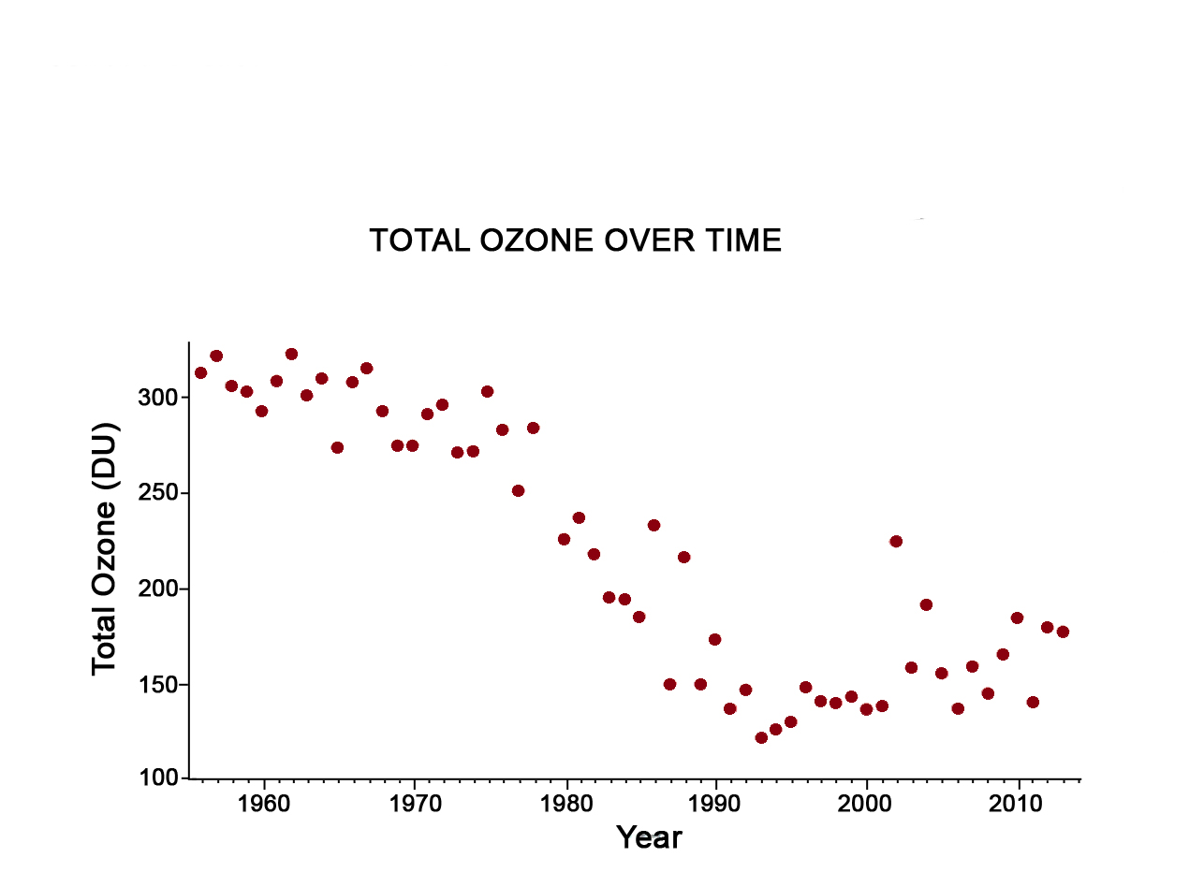
HOW WE MEASURE OZONE: The Dobson Unit is the most common unit for measuring ozone concentration. One Dobson Unit is the number of molecules of ozone that would be required to create a layer of pure ozone 0.01 millimeters thick at a temperature of 0 degrees Celsius and a pressure of 1 atmosphere (the air pressure at the surface of the Earth). Over the Earth’s surface, the ozone layer’s average thickness is about 300 Dobson Units or a layer that is 3 millimeters thick.

Look at the following graph and then answer the questions below.

Source: http://ozonewatch.gsfc.nasa.gov/facts/history_SH.html

1.What is the label of the y-axis? ____________________________________________

2. Explain what this means: ________________________________________________

_______________________________________________________________________

_______________________________________________________________________

_______________________________________________________________________

3. What is the label of the x-axis? ____________________________________________

4. What is the normal amount of total ozone (DU)? ________________________________________

5. What is the range of ozone levels from 1956 – 1963? __________________________

6. What do you notice happening from 1978 – 1990? ____________________________

_______________________________________________________________________

_______________________________________________________________________

7. Why do you think this may be happening? __________________________________

_______________________________________________________________________

8. What do you notice happening after 2000? ___________________________________

_______________________________________________________________________

_______________________________________________________________________

9. How can you explain this? ________________________________________________

_______________________________________________________________________

_______________________________________________________________________
Montreal Protocol of 1987

Using the following site, answer the questions below:
United Nations Environment Programme - http://ozone.unep.org/new_site/en/montreal_protocol.php
Environmental Protection Agency - http://www.epa.gov/ozone/intpol/history.html

A. What was the Montreal Protocol of 1987?

B. Why was it created?

C. What countries were involved?

D. What products were banned due to this protocol?

E. Are some of these products still in use? Explain.

F. Is it possible to continue to use products that were banned and continue to fix them instead of buying new products?

G. In what year was the Protocol last updated?

Using the information you have researched about the Montreal Protocol of 1987 – look at the graph on the previous worksheet and answer the following question:

What happens to the total ozone after 1990? How can you explain this?

__________________________________________________________________________

__________________________________________________________________________

__________________________________________________________________________

__________________________________________________________________________

__________________________________________________________________________

__________________________________________________________________________

__________________________________________________________________________

__________________________________________________________________________

__________________________________________________________________________

__________________________________________________________________________

__________________________________________________________________________

__________________________________________________________________________

