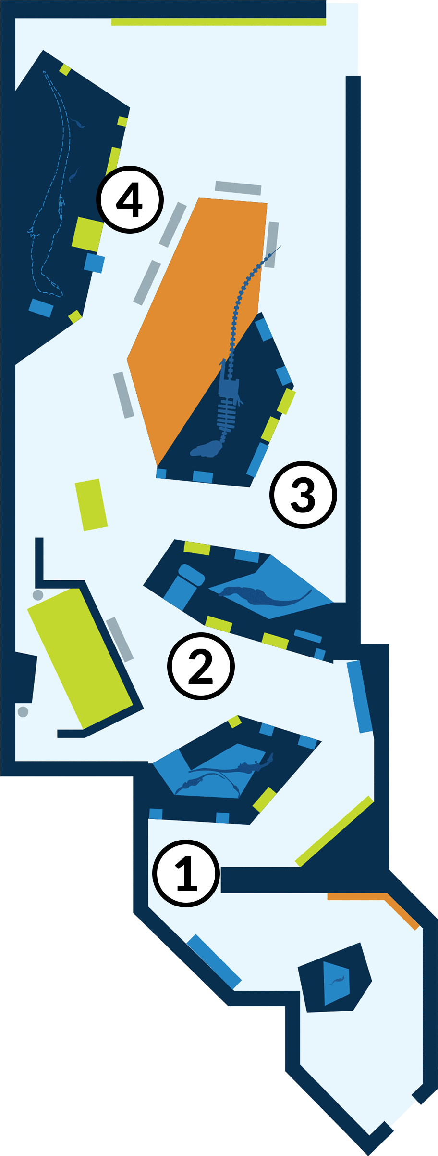
Student Worksheet NAME: _______________________________________________

Welcome to the American Museum of Natural History! Fossils show how animals changed over time and how they are related to one another. While fossils also reveal what ancient animals looked like, they keep us guessing about the animals’ colors, sounds, and most of their behavior. So scientists also observe animals living today for clues to what ancient animals may have looked like, how they may have moved and behaved, and how they may have interacted with other animals in the ecosystem.

In the T. rex: The Ultimate Predator exhibition, you will explore similarities and differences between Tyrannosaurus rex, its ancient and living relatives, and other living animals for clues about this predator.

These stops are highlighted in the worksheets:

STOP 1: “Meet the Family” Section

STOP 2: “Getting Big” Section

STOP 3: “Getting Bad” Section

STOP 4: “Sensitive Side” Section

STOP 1: “Meet the Family” Section

- Observe the model of Dilong paradoxus and read the “Fierce and Feathered” panel. What evidence do scientists use to hypothesize that this animal most likely had simple feathers covering its entire body?

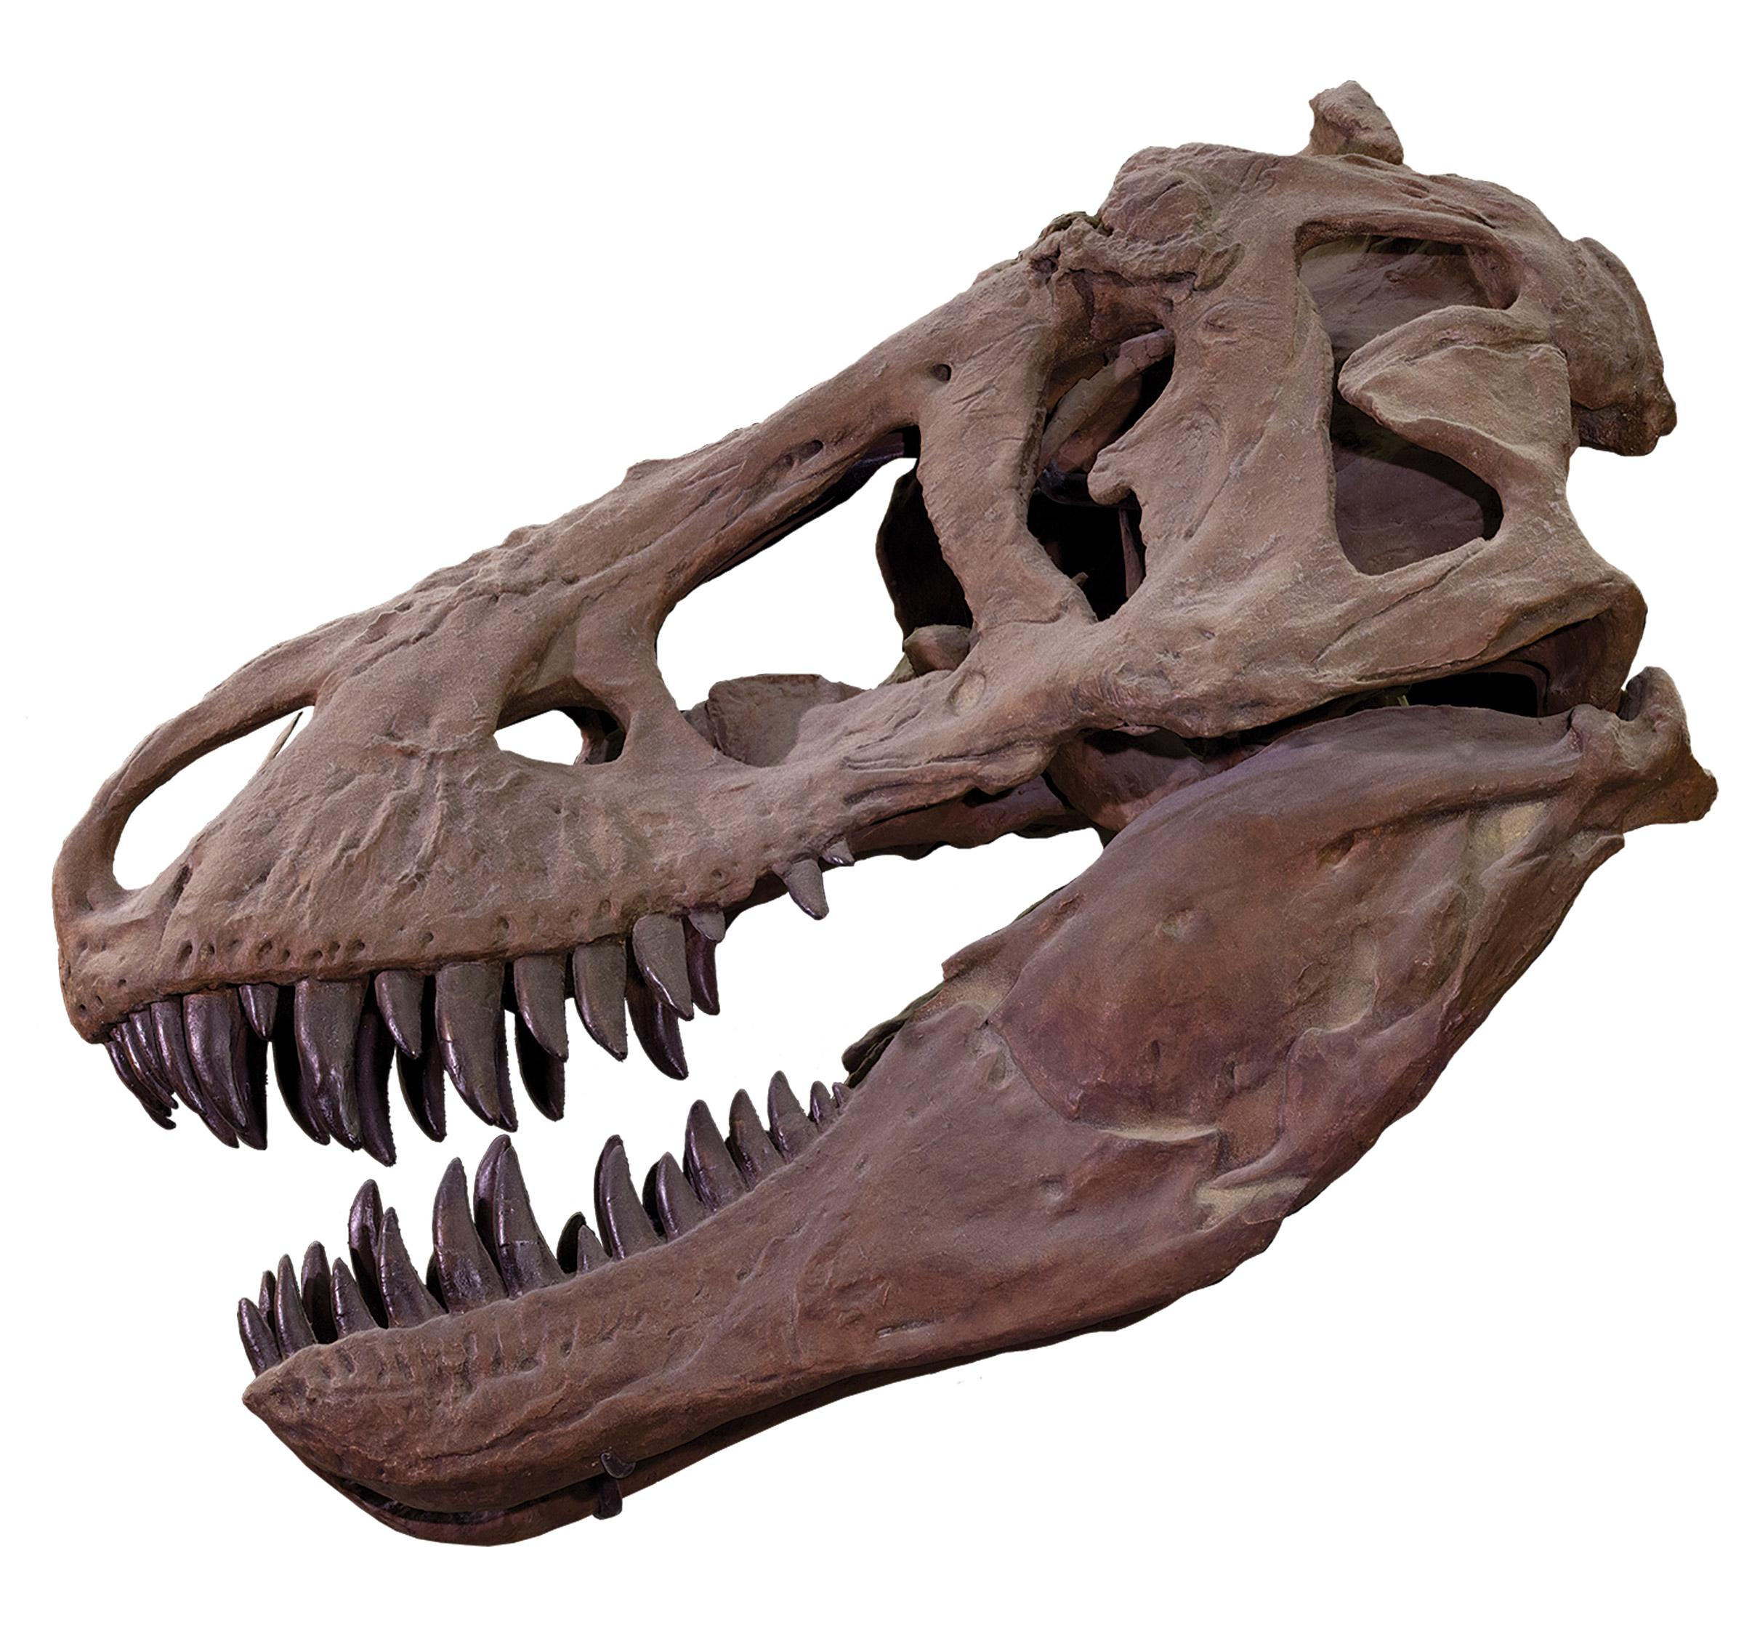

- Observe the “T. rex Traits” wall.
Related species often look similar because they share a common ancestor, from whom they inherited similar traits. This is true of tyrannosaurs. What three traits do all tyrannosaurs share?
Label them on the skull.

- Try the “Tail Balance” interactive and read the “Bodies in Balance” panel. What evidence do scientists use to hypothesize about how T. rex used its tail?

STOP 2: “Getting Big” Section

- Examine the Tarbosaurus adult skull and juvenile skeleton. Sketch each specimen in the boxes below.

adult skull | juvenile skeleton

Scientists think that Tarbosaurus, like T. rex, lived a very different life as a juvenile than it did as an adult. Compare the adult and juvenile specimens. What does each specimen tell you about how the animal may have hunted at different ages?

- In the “Tarbosaurus” panel, read about ecological niches. How does the life history of the living animal Komodo dragon help support the inference that adult T. rex and Tarbosaurus occupied different ecological niches than their respective juvenile forms?

STOP 3: “Getting Bad” Section

- Examine fossils of teeth.
Sketch a T. rex tooth.

Read the “Tough Teeth” panel. What inference can scientists make by comparing the teeth of a modern predator such as a lion to those of T. rex?

- Read the “Room at the Top” panel. Scientists think that T. rex was not the only top predator in its ecosystem; it shared this title with Alioramus and Tarbosaurus. How could these animals have coexisted?

What evidence from animals living today do scientists use to infer that multiple top predators can coexist in an area?

- Explore the coprolite and related panels. T. rex could digest bone. How do scientists know that?

STOP 4: “Sensitive Side” Section

- Read the “Eyes of a Killer” panel. What evidence do scientists use to hypothesize that T. rex may have seen in the ultraviolet spectrum?

What are the similarities between the eyes of T. rex and the mountain lion? How does this evidence support the idea that T. rex was a predator?

- Sketch the Daspletosaurus jawbone and mark the small holes.
What do scientists think is the most probable explanation for these structures? Why?

Read the “Touchy Feely” panel. What evidence supports the idea that T. rex had a very sensitive face?

- Read the “Headgear,” “Scales and Feathers,” and the “Hear Me Roar!” sections. Record one interesting information about T. rex appearance or sound and the evidence that supports it.

