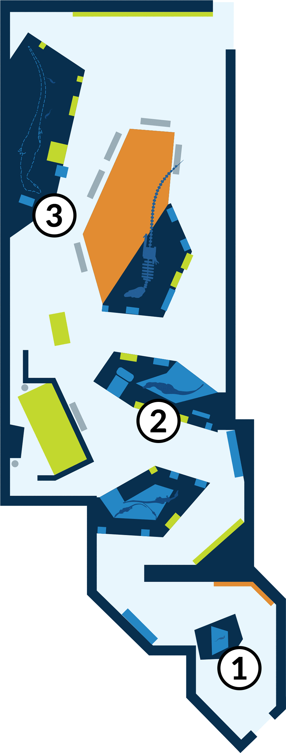
Student Worksheets NAME: _________________________________________

Welcome to the American Museum of Natural History!
When you think of Tyrannosaurus rex, you may think of a huge and ferocious predator. But what was this animal like when it was younger?
At the Museum today, you’ll see what T. rex may have looked like at different ages. You’ll also explore how it lived, hunted, and survived as it grew up.

These stops are highlighted in the worksheets:

STOP 1: T. rex Baby (age 1)

STOP 2: Juvenile T. rex (age 4)

STOP 3: Adult T. rex (age 20)

STOP 1: T. rex Baby (age 1)
- Sketch the one-year-old T. rex. Label its features.

- Try the “Survival Challenge” activity. What is a major danger that a T. rex baby faces?

How can a T. rex baby keep itself safe?

STOP 2: Juvenile T. rex (age 4)
- Sketch the
model of the four-year-old
T. rex.
Label its
features.

- Read the information about young T. rex on the panels around the model. How is this four-year-old T. rex different from the one-year-old T. rex you observed before?

- Read the information in front of the model. What are three ways that this four-year-old T. rex is different from an adult T. rex?

- Read the information on growth rings.
How often do the rings form? |  | What does the space between growth rings show?

During what time of its life did T. rex grow the fastest?

- Try the “Survival Challenge” activity. How could a four-year-old T. rex successfully attack an armored dinosaur? Why did it need to attack that way?

STOP 3: Adult T. rex (age 20)
- Sketch the
model of the adult T. rex.
Label its features.

- Try the “Survival Challenge” activity. What is the adult’s best strategy for catching its prey? Why?

- Explore the section about T. rex jaws, teeth, and arms.
How were adult T. rex teeth different from those of young T. rex and other tyrannosaurs?

What did these teeth allow T. rex to do?

What are some reasons T. rex may have had tiny arms?

