Student Worksheets NAME: _____________________________________________

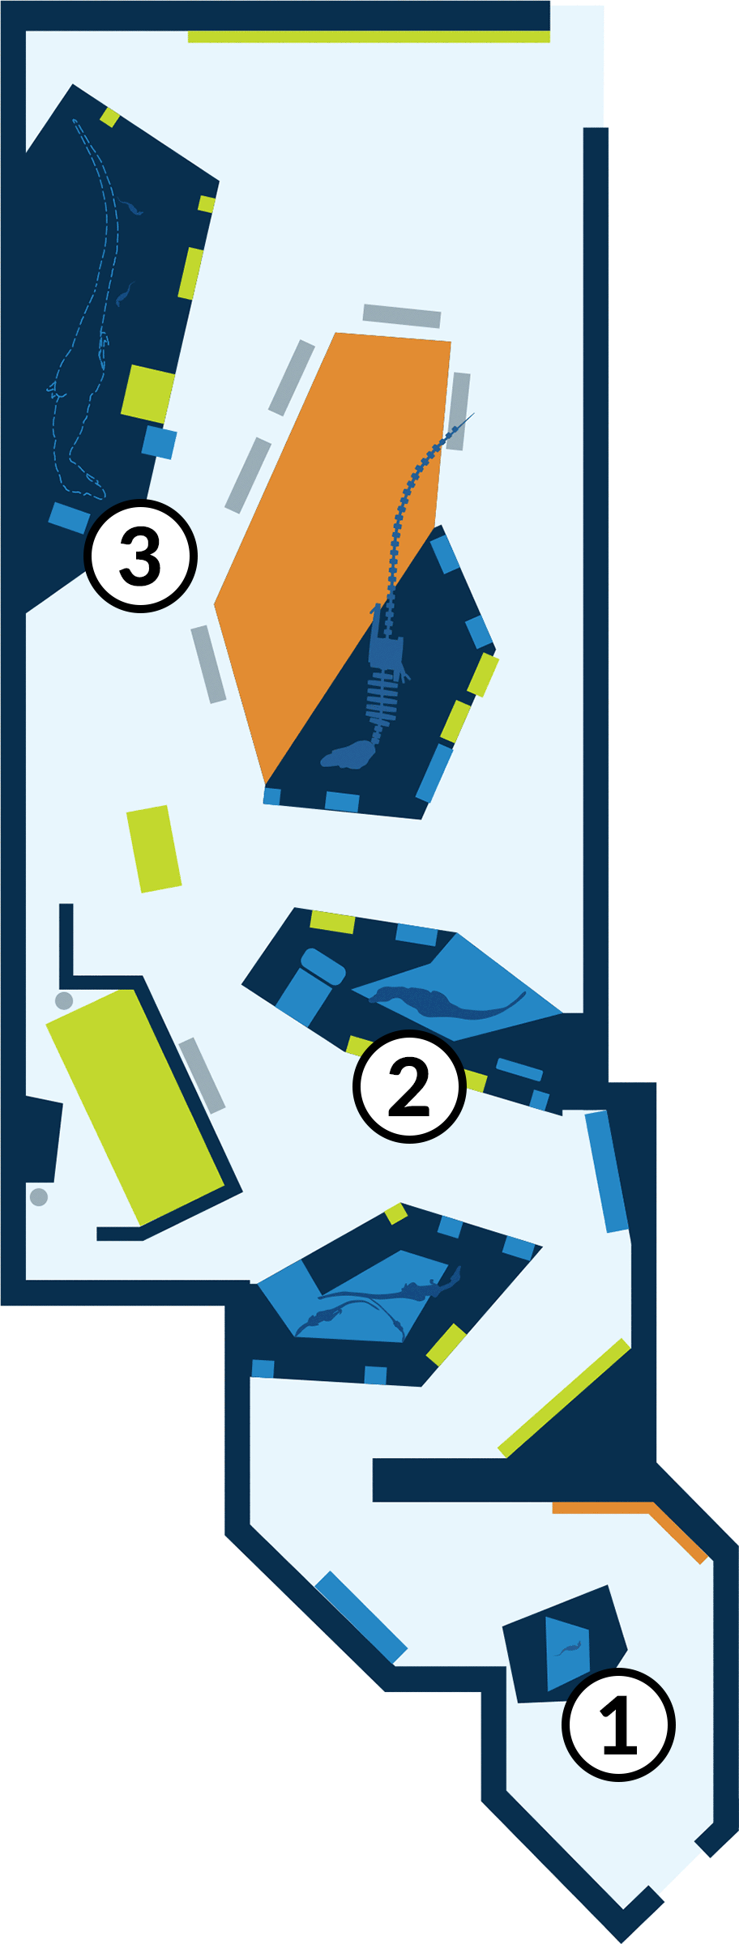
Welcome to the American Museum of Natural History!
When you think of Tyrannosaurus rex, you may think of a huge and ferocious predator. But what was this animal like when it was younger?
At the Museum today, you’ll see what T. rex may have looked like at different ages.

These stops are highlighted in the worksheets:

STOP 1: T. rex Baby (age 1)

STOP 2: Juvenile T. rex (age 4)

STOP 3: Adult T. rex (age 20)

STOP 1: T. rex Baby (age 1)

- Look at the model of the one-year-old T. rex. Talk to your partner about what you notice.
Then, draw a picture of what you see. Label the different parts of your drawing.

STOP 2: Juvenile T. rex (age 4)

- Look at the model of the four-year-old T. rex. Talk to your partner about what you notice.
Then, draw a picture of what you see. Label the different parts of your drawing.

Talk to your partner: How is this four-year-old T. rex different from the one-year-old T. rex you observed before? Write notes below.

STOP 3: Adult T. rex (age 20)
- Look at the model of the twenty-year-old T. rex. Talk to your partner about what you notice. Then, draw a picture of what you see. Label the different parts of your drawing.

