ANSWER SHEET | Classifying Dinosaurs Based on Fossils

PART I: IDENTIFYING THE FEMUR

- Discuss the distribution of the four different character states of the fourth trochanter (A, B, C, and D) on the dinosaur cladogram.

- How do you explain the presence of A, B, and C types of fourth trochanters among the ornithischians?

- Based on this analysis, in what groups of the phylogeny could you place the fossil? Explain your reasoning.

PART II: FURTHER IDENTIFYING THE FEMUR
4. Fill out the table with descriptions of the fourth trochanter for each type of dinosaur.

 | Position of the fourth trochanter relative to the midline of the femur | Shape of the fourth trochanter
Heterodontosaurus
Psittacosaurus
Hypsilophodon
Tenontosaurus
Mystery femur

5. In which group do you think the mystery fossil belongs? Summarize your reasoning in a short paragraph.

PART III: IDENTIFYING A SKELETON

- For each of the 11 characters, use this table to record the condition observed in the fossilized skeleton. Does it show the shared derived state or the ancestral condition? 1, 2, and 3 are filled out for you as a model.

1. Hole in the hip socket: The fossil has a hole in the hip socket, which is a shared derived condition for the Dinosauria clade. (Note: All branches in the Dinosauria clade are marked with black squares on the cladogram.) | 7. Number of fingers:
2. Grasping hand: The fossil has a grasping hand. This is a shared derived condition for saurischian dinosaurs. (Note: All branches in the Saurischia clade are marked with black squares on the cladogram.) | 8. Uncinate process connecting the ribs:
3. Femoral fourth trochanter: The femur does not have a well-developed fourth trochanter. This is a derived character for the Ornithischia clade. Since our fossil does not have this character, it does not help us with the identification of the fossil. (Note: The Ornithischia clade is marked with a gray square on the cladogram.) | 9. Scapula/humerus length:
4. Furcula: | 10. Neck length:
5. Length of the leg bones: | 11. Relative length of the fingers:
6. Fusion of the hip bones:

- Below is a cladogram showing the relationships among dinosaur groups relevant to the Gobi Desert fossil skeleton investigation. Use the table to visualize the distribution of the shared derived characters included in the analysis. For example, the distribution of the character “presence of a hole in the hip socket” is a shared derived character state of dinosaurs. On the cladogram, use the fill or highlight function to color in the cells for all the branches in the clade that share the derived character state. The first three characters are completed for you to use as models. You may want to use one color to indicate characters that your fossil has and another color to indicate clades that do not include the fossil.
- Summary for Part III: What group of dinosaurs does the fossil in Figure 5 of the instructions come from? Explain your reasoning based on the characters you examined and what they tell you about the classification of this dinosaur fossil.

____________________________________________
PART III: IDENTIFYING A SKELETON
CLADOGRAM
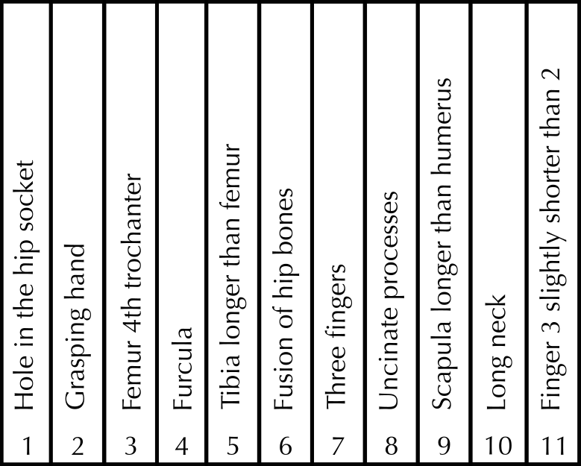
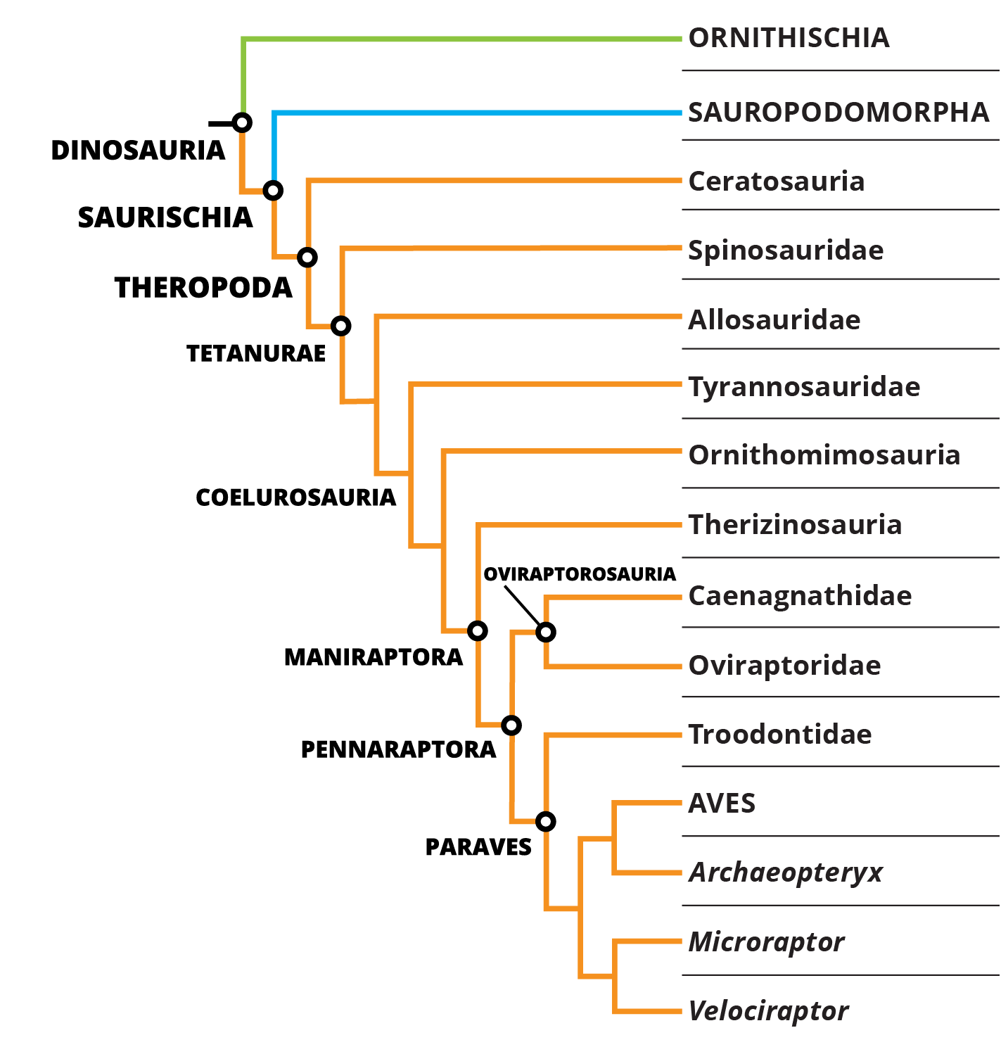 |  |  |  |  |  |  |  |  |  |  |  | 